ListingPilot: Marketplace Listing Automation
Proposal for [Client name] · Prepared by IterativeTech, Jaipur

Summary
ListingPilot turns one product sheet into complete, checked listings on Amazon, Flipkart and Meesho, replacing manual entry on each portal. Your team keeps one master catalogue; the system writes the listing content, checks it against each marketplace's rules, and publishes it after your approval.
What you get | AI listing creation, error checks, approval dashboard, publishing to Amazon and Flipkart, ready-to-upload Meesho files
How it connects | Official seller APIs only (Amazon SP-API, Flipkart Seller API); no bots or scraping

Your current situation
Today your team types each product by hand into three seller portals. Every portal has different fields and rules, so the same product is entered three times and errors are found only after a listing is rejected.
- Repeated work: one product means three separate entries on Amazon, Flipkart and Meesho.
- Missed or wrong specs: missing sizes, materials or category fields lead to rejected or hidden listings.
- Uneven quality: titles and bullet points vary by who wrote them, with weak search keywords.
- Slow launches: new products wait in a queue for data entry.
- No single view: nobody can see at a glance which products are live where, and which are stuck.
In the pilot we will measure your current time per listing and rejection rate, so the improvement is proven on your own numbers.

The solution
Your team updates one master sheet. ListingPilot does the writing, checking and publishing, and shows only what needs a human decision.
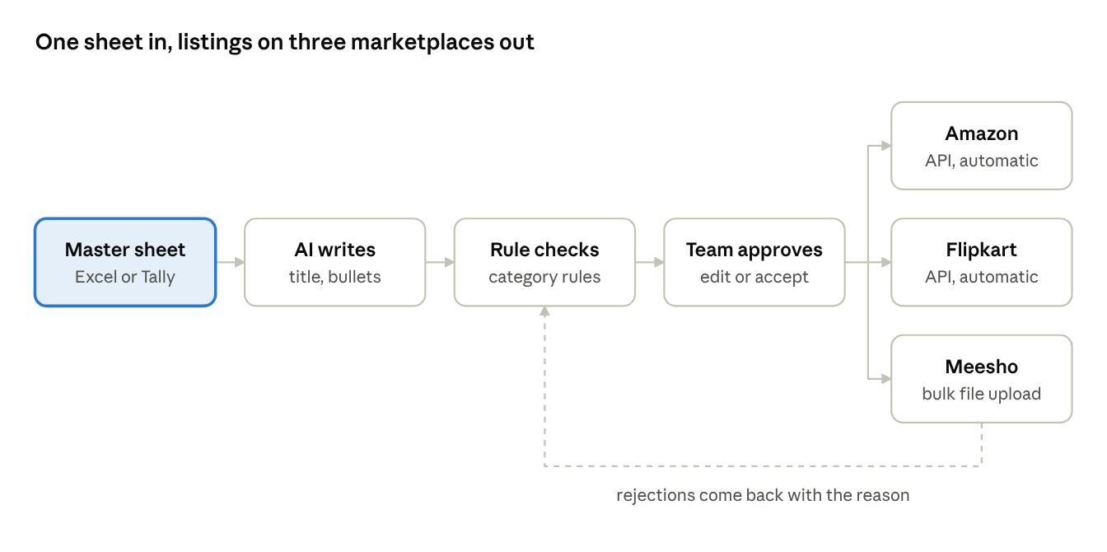
ListingPilot flow · one catalogue, three marketplaces
Nothing goes to a marketplace until it passes the rule checks and your team approves it. Amazon and Flipkart listings are published automatically through their official seller APIs. Meesho has no seller API, so ListingPilot fills Meesho's own upload templates and your team uploads them in a few minutes.
What changes for your team
- One product sheet replaces three separate data-entry jobs.
- Listing content is written in your brand voice, with the keywords shoppers search for.
- Missing specs and banned claims are caught before submission, not after rejection.
- One dashboard shows every SKU's status on every marketplace.

Scope
This proposal covers the core listing tool only. Ads and WhatsApp can be added later as separate projects.
Included
Area | What is delivered
Master catalogue | One Excel or Google Sheet template for all products; import from your existing sheet or Tally export
AI listing content | Title, 5 bullet points, description and search keywords per product, adapted to each marketplace's limits
Rule checks | Required fields per category, title length, photo count and banned claims, checked before anything is sent
Review and approval | Web dashboard to review, edit and approve drafts; status of every SKU on every marketplace
Amazon | Create and update listings, price and stock through the official SP-API
Flipkart | Create and update listings, price and stock through the Flipkart Seller API
Meesho | Ready-to-upload bulk files in Meesho's category templates (Meesho does not offer a seller API)
Error report | Rejections from each marketplace shown with the reason, fixed and resent from one place
Training | Two sessions for your team, plus a short user guide
Support | Bug fixes, monitoring and marketplace rule updates for the support period
Not included
- Amazon, Flipkart or Meesho ads management
- WhatsApp integration (photo-to-listing, daily owner summary)
- Order processing, shipping labels and returns
- Product photography, image editing and A+ content design
- Marketplace fees, ad spend and Brand Registry costs
- Automatic stock or order sync with Meesho

Delivery plan
We prove results on your own products first, then extend to the other marketplaces.
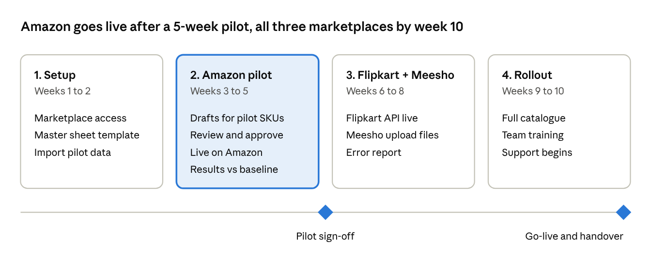

What we need from you
Marketplace access takes the longest to approve, so we start it in week 1 alongside the sample data.
For all marketplaces
- ☐ Current product data for 50 to 100 pilot SKUs (Excel, Tally export or supplier catalogue)
- ☐ Product photos, ideally 5 or more per product, with one on a plain white background
- ☐ Size charts, materials and care details for each category
- ☐ Brand name, tone of voice, target keywords and claims to avoid
- ☐ One point of contact and one person who approves listings
- ☐ Current listings per month and time taken per listing, for the baseline
Amazon
- ☐ Professional selling account
- ☐ Primary account user registers as a private developer in Seller Central and requests the listing, pricing and inventory roles (we guide you on a short call)
- ☐ Brand Registry and category approval status
- ☐ List of existing ASINs
Flipkart
- ☐ Registered Flipkart seller account
- ☐ Developer access created from Manage Profile → Developer Access; credentials stay on your side and are never shared outside your account
- ☐ Existing listing IDs and brand approvals
Meesho
- ☐ Supplier panel access for the person who will upload files
- ☐ Latest category templates from your panel
- ☐ Existing Meesho SKU list

Why IterativeTech
We build AI automation that plugs into the systems a business already runs, using official integrations only.
- Safe by design: official marketplace APIs, a human approval step and rule checks before every submission, so your seller accounts stay protected.
- Built for Indian sellers: Amazon.in, Flipkart and Meesho from one catalogue, which Amazon's own tools and Helium 10 do not cover.
- Proven delivery: we built CarCred, an AI layer running on a live dealership auto-lending platform, connecting AI with CRM and messaging systems.
- Local and reachable: a Jaipur team you can meet, with direct access to the people building your system.

Assumptions and terms
- You own your product data, marketplace accounts and API credentials at all times. On exit, we hand over your full master catalogue.
- Timelines depend on marketplace access approvals and on receiving pilot data in week 1.
- Marketplace fees, ad spend and Brand Registry costs are paid by you directly to the marketplace.
- Marketplace rule or API changes are handled under the monthly support plan.
- AI drafts are reviewed and approved by your team before publishing; final listing content is your responsibility.
- New features beyond this scope, such as ads or WhatsApp, are quoted separately.
- Either party may end the monthly support with 30 days' notice after the minimum 6-month term.
- This proposal is valid for 30 days from its date.

